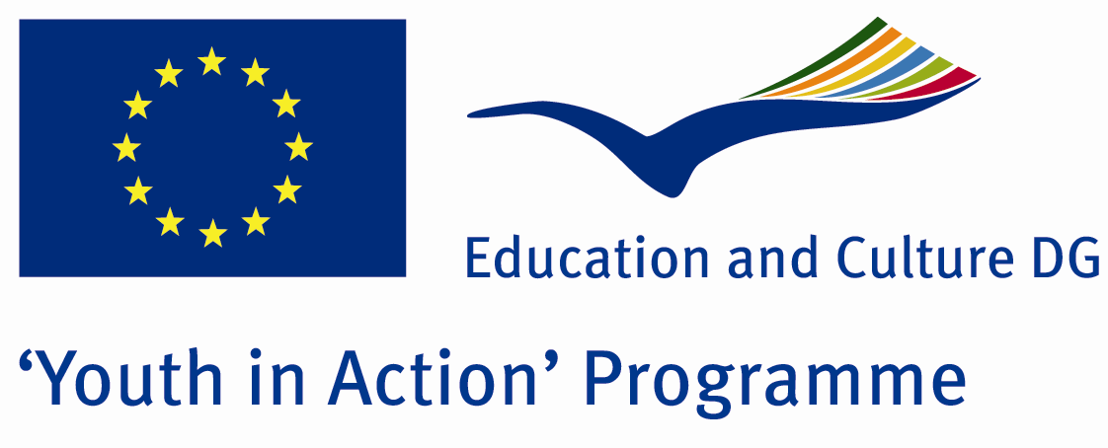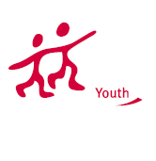

Action 1.1
Project Summary;
Our action 1.1 project will be realized at a village in Muğla and its main aims are charity, advantages and disadvantages of technology, natural life, organic products and democracy.it will go on during 8 days. .In this project, we try to live all the village life.We'll produce our foods ourselves as organic and we never use technology...We aim that we learn how we can live without technology
Project Title; PURE LIFE
Date and Venue ;14-21 JULY 2012 Turkey
Place: MUĞLAr

Target Group ; Municipalities, City Councils and Non-Governmental organizations,
youth groups,culture and art groups,e.t.c

Participants ; 5 people from each country (over 18 -25 ). Totally 8 countries.

Conditions ; Accommodation, board and programme costs will be financed through European Commission Youth in Action Programme . Travel costs will be reimbursed in 70% (APEX Tarrifs). Organizations from all 27 EU member countries plus Liechtenstein , Norway and Iceland are eligible to take part.

Working language: English

Organisator group: Cınema Lovers Group

How to apply: If you are interested, please send your Part III forms to
by e-mail please (in word file). Scan Part3 format is enough for application.(Fulfilled Part III which you can find in the attachment, of course signed and stamped) ..

Contact e-mail: cinemaloversgroup@gmail.com

Deadline for application; until 15th October 2011.

